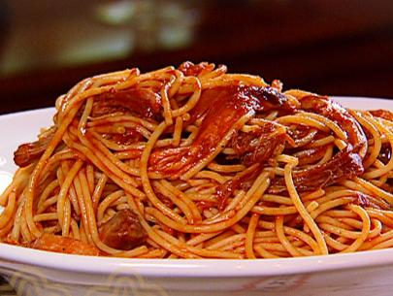
BBQ Spaghetti
Ingredients:
1 tablespoon olive oil
1 small green bell pepper, chopped
1/2 yellow onion, finely chopped
1 tablespoon garlic salt
3 1/2 cups Neely's BBQ sauce, recipe follows
1 pound pork, beef, or chicken, cooked and chopped into bite-size pieces
1 pound spaghetti
Neely's BBQ Sauce
2 cups ketchup
1 cup water
1/2 cup apple cider vinegar
5 tablespoons light brown sugar
5 tablespoons sugar
1/2 tablespoon fresh ground black pepper
1/2 tablespoon onion powder
1/2 tablespoon ground mustard
1 tablespoon lemon juice
1 tablespoon Worcestershire sauce

Directions:
In a large skillet, heat olive oil over medium heat. Saute the pepper and onion until softened, 1 to 2 minutes. Stir in the garlic salt. Add the BBQ sauce and bring to a boil. Reduce the heat to a low simmer and add the chopped meat.
2 Meanwhile, fill a large pot with water and bring to boil. Season liberally with salt and add spaghetti. Cook until al dente (firm but not hard), about 7 minutes, and drain. Toss spaghetti with sauce.

Neely's BBQ Sauce
3 In a medium saucepan, combine all ingredients. Bring mixture to a boil, reduce heat to simmer. Cooked uncovered, stirring frequently, for 1 hour 15 minutes.

