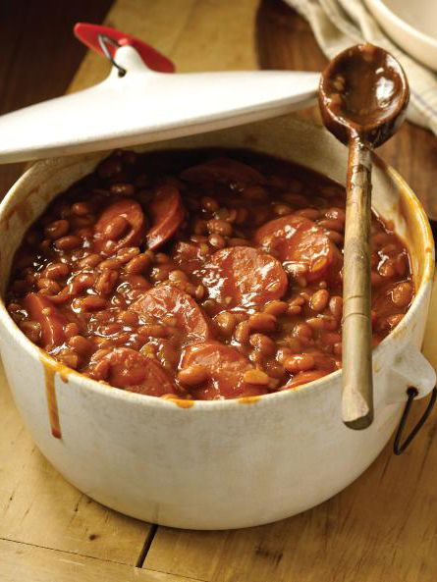
NEELY’S BAKED BEANS

Ingredients
- 1 tablespoon olive oil
- 1 red bell pepper, chopped
- 1/2 onion, chopped
- 2 cloves garlic, chopped
- 2 (28-ounce) cans baked beans
- 1/2 cup brown sugar
- 1/3 cup Neelys BBQ seasoning, recipe follows
- 1/4 cup molasses
- 1 cup Neelys BBQ sauce, recipe follows
- 3/4 cup chopped pork or beef brisket
- Neelys BBQ Seasoning:
- 1 1/2 cups paprika
- 3/4 cup sugar
- 3 3/4 tablespoons onion powder
- Neelys BBQ Sauce:
- 2 cups ketchup
- 1 cup water
- 1/2 cup apple cider vinegar
- 5 tablespoons light brown sugar
- 5 tablespoons sugar
- 1/2 tablespoon fresh ground black pepper
- 1/2 tablespoon onion powder
- 1/2 tablespoon ground mustard
- 1 tablespoon lemon juice
- 1 tablespoon Worcestershire sauce
- Preheat oven to 275 degrees F.
- In a large Dutch oven, heat oil over medium heat. Saute the red pepper, onion and garlic until softened, about 2 minutes. Add the baked beans and remaining ingredients and bring to a low simmer. Cover the beans and place in the preheated oven. Bake for 45 minutes.
Neelys BBQ Seasoning:
- Add all ingredients to a bowl and stir until combined. Keep in an airtight container for up to 6 months.
Neelys BBQ Sauce:
- In a large saucepan, combine all ingredients. Bring mixture to a boil, reduce heat to a simmer. Cook uncovered, stirring frequently, for 1 hour 15 minutes.
- Yield: 3 1/2 cups
Recipe courtesy of The Pat Neely

