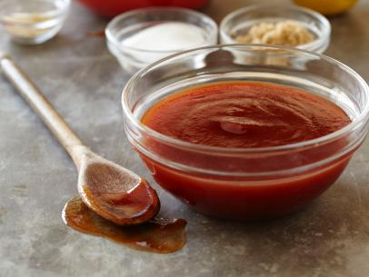

NEELY’S BBQ SAUCE

Ingredients
- 2 cups ketchup
- 1 cup water
- 1/2 cup apple cider vinegar
- 5 tablespoons light brown sugar
- 5 tablespoons sugar
- ½ tablespoon tomato pasta
- ½ tablespoon cumin
- 1/2 tablespoon fresh ground black pepper
- 1/2 tablespoon onion powder
- 1/2 tablespoon ground mustard
- 1 tablespoon liquid smoke
- 1 tablespoon lemon juice
- 1 tablespoon Worcestershire sauce

Directions
- In a medium saucepan, combine all ingredients. Bring mixture to a boil, reduce heat to simmer. Cook uncovered, stirring frequently, for 1 hour 15 minutes.
Recipe courtesy of The Pat Neely

